**Project Proposal**

1. Project Title and Team Members :-

**Title :- Inflation at a Global Level**

**Team :-**

Aniv Chakravarty ([anivchakravarty@my.unt.edu](mailto:anivchakravarty@my.unt.edu)):-

* Data Cleaning
* Analyzing data using basic visualizations.
* Researching possible visualization strategies for dashboard.
* Implementation of certain parts of dashboard

Shridhar Kshirsagar ([shridharkshirsagar@my.unt.edu](mailto:shridharkshirsagar@my.unt.edu)):-

* Research on data to be presented to the user via dashboard which will provide meaningful domain/business insights.
* Making the dashboard more interactive and user friendly.
* Implementation of Dashboard using a programming language.

2. Goals and Objectives:

**Motivation:-**

* Economy of a nation plays an important role in deciding the essential factors contributing to its growth. On a democratic scale, it widens the gap between the nation’s government and its citizens. On a citizen level, inflation may have a considerable impact on the belief of people in their government.
* Tracking inflation in a country is as valuable as tracking the rapidly changing stock market.
* Although, there still hasn’t been a proper utilization of data analytics resources to study and predict the inflation at a global level, when compared to the booming field that is stock market prediction.
* Hence, we propose a system to track and understand the nature and trends of inflation at a global level using different Data Analytics and Visualization techniques.
* Tracking inflation can be beneficial at many levels. One of the advantages being that the government can plan better ahead of time to take care of the fact that the impact on its citizens is cut down to bare minimum.
* Additionally, it will also enable the authorities to investigate and tackle the root of inflation due to a better understanding ahead of time.
* At a citizen level, this system will help the people to be more aware of the financial situation of their country as well as make necessary amends and preparations.

**Significance:**

We observed various different plots created visualizing different aspects of the inflation data through different line, bar and geographical plots [[2](https://inflationdata.com/inflation/images/)] as well as customized line plots for depicting income as in [[3](https://www.anychart.com/blog/2021/11/12/visualizing-data-prices-emissions-workforce-palm-oil/#more-13940)]. The closest dashboard we found online was from the international monetary fund [[4](https://www.imf.org/external/datamapper/PCPIPCH@WEO/OEMDC/ADVEC/WEOWORLD)] which provides an interactive interface for geographic heatmap with a line scale trend for displaying average economic data but does not break down by different economic sectors and visual and the global inflation rate tracker [[5](https://www.ft.com/content/088d3368-bb8b-4ff3-9df7-a7680d4d81b2)] which made use of line and geographic plots for fixed years and a few major countries. We aim to provide a dashboard with few more visualizations compared to these. These visualizations do not provide much room to drill down and drill up on the data with limited interactivity in terms of mouse clicks. While these front end dashboards provide great visualizations our project aims to provide a more interactive approach with more ways to view the data.

**Objectives:**

Our objective is to build a tool, analyze the data and find answers to key questions such as,

* What is the current rate of inflation?
* Which countries have the highest inflation rate? and
* What are the trends for each country?

We also need to provide the data in crisp, easy to understand visualizations in an interactive dashboard.

For the first increment we plan on doing exploratory data analysis and building the application.

For the second increment we will be adding the extra features and user interface.

**WorkFlow:**

We first start with cleaning the dataset. Once the data is ready we perform exploratory analysis on different visualization forms to pick a set of visualizations to have in the application. Figure 1 shows the workflow of our project plan. The story boarding process in the user interface and experience would determine what the user sees and how the user interacts with the main dashboard and respective features as they are added and would be tied to development. We will build a core set of features for the initial phase 1 of the project so that the app works first, we then proceed with the iterative cycles to add in further features. The analysis portion would be to determine which visualizations provide the details in an understandable format in order to avoid excessive clutter on the dashboard. We plan to first start with barcharts, spheres, scatterplots and then branch out to more complex plots.

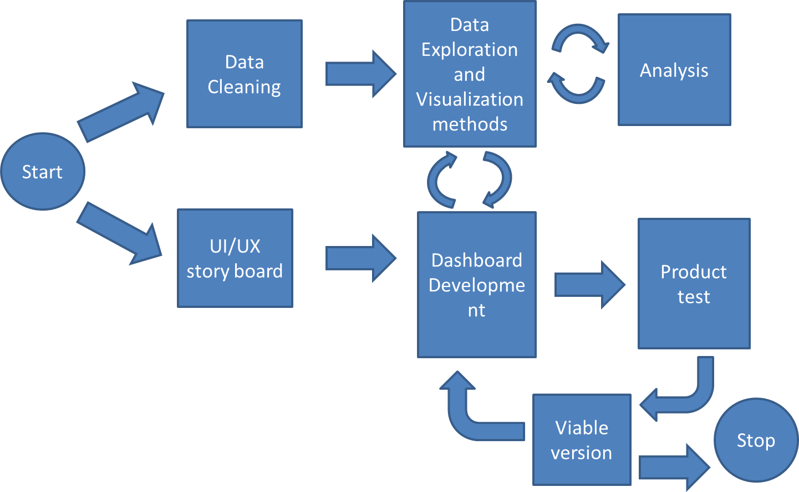

Figure 1: Project Workflow

In terms of data workflow, our dashboard will be fetching quantitative data from a storage repository while having an interactive module and sub visualizations that would form supplementary visualizations on context based on Figure 2. While this is an initial proposal our workflow may change based on how our ui/ux storyboard goes through and update based on that.

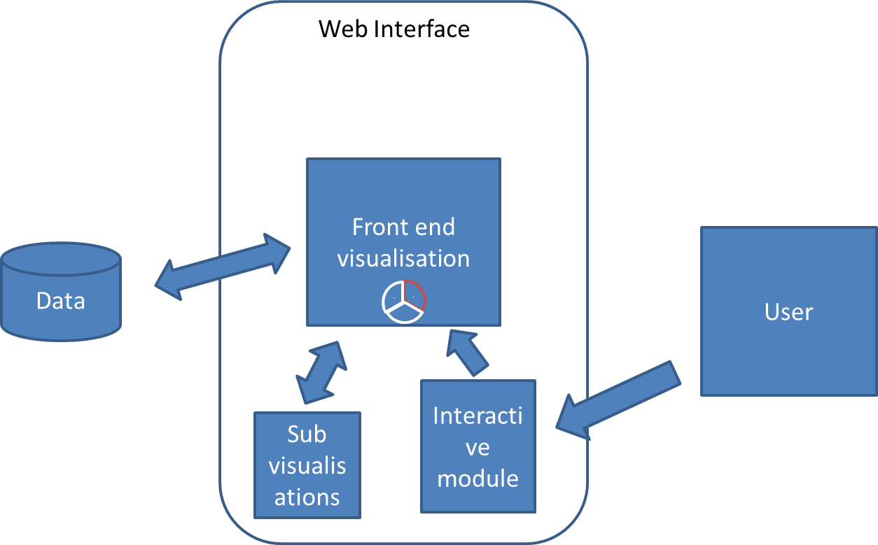

Figure 2: System Workflow

**Features:**

The dataset [[1](https://www.kaggle.com/datasets/belayethossainds/global-inflation-dataset-212-country-19702022)] contains inflation data of over 206 countries in the time frame of 1970 to 2022 across four domains of consumer, producer, food, energy costs. This allows us a lot of room in terms of visualization of the data. So we plan to try and incorporate the feature listed below in our tool in an iterative method starting with core visualization parts first and adding features on top.

* Drill up and drill down options
* Navigation
* Interactive visualization
* Dashboard user interface
* Dynamic visualization changer
* Annotation options
* Multiple panels
* Colorblind features
* Customization options
* Web application
* Feature engineering options to perform grouping, numerical operations on the data.
* Animations
* Print report

Github: <https://github.com/AnivChakravarty/global_inflation_viz>

Contributors : AnivChakravarthy and cosmos225(Shridhar Kshirsagar)

**3. References**

|  | [1] HossainDS, “Global inflation dataset - (1970~2022),” *Kaggle*, 21-Feb-2023. [Online]. Available: <https://www.kaggle.com/datasets/belayethossainds/global-inflation-dataset-212-country-19702022>. [Accessed: 10-Mar-2023]. |
| --- | --- |
|  | [2] T. McMahon, “What is quantitative tightening?,” *Inflation Calculators from InflationData.com*, 14-Mar-2023. [Online]. Available: <https://inflationdata.com/inflation/images/>. [Accessed: 20-Mar-2023]. |
|  | [3] “Visualizing data on prices, emissions, workforce, Palm Oil - Dataviz Weekly,” *AnyChart News*, 12-Nov-2021. [Online]. Available: <https://www.anychart.com/blog/2021/11/12/visualizing-data-prices-emissions-workforce-palm-oil/#more-13940>. [Accessed: 20-Mar-2023]. |
|  | [4] “IMF Datamapper,” *IMF*. [Online]. Available: <https://www.imf.org/external/datamapper/PCPIPCH@WEO/OEMDC/ADVEC/WEOWORLD>. [Accessed: 20-Mar-2023]. |
|  | [5] V. Romei and A. Smith, “Global inflation tracker: See how your country compares on rising prices,” *Financial Times*, 14-Mar-2023. [Online]. Available: <https://www.ft.com/content/088d3368-bb8b-4ff3-9df7-a7680d4d81b2>. [Accessed: 20-Mar-2023]. |